Maths and Numeracy | Language, Literacy and Communication | Science and Technology | Humanities | Health and Well Being | Expressive Arts
Plan a day out for a family of 4 to a Welsh tourist attraction. You will need to budget for travel, entrance fees and money for the gift shop, under £100. | Write a poem about Wales. You can choose which type of poem you write e.g. acrostic, haiku, rhyming. | Research the life cycle of a daffodil. Draw and write about the process it goes through. | Research and write 10 facts about a famous Welsh person. | Find an online recipe for something traditionally Welsh, e.g. Cawl or Welsh cakes. Ask a family member to help make your recipe!
Research the heights of the 10 highest mountains in Wales and display the information in a table. | Imagine you are opening up a new restaurant in Swansea. Create a menu of your favourite food – in Welsh! | Log in to HWB and Office365. Create a PowerPoint about different tourist destinations in Wales. | Draw a map of Wales on an A4 piece of paper. Can you label the different counties and rivers? | Children’s rights in Wales are really important. Design a poster about the history of Children’s rights in Wales. | Make, paint or draw a daffodil, our Welsh emblem.
Find out the hourly minimum wage of an 18-year-old working in Wales. How much would they earn in a 7-hour day? | Write a newspaper report about a famous Welsh sporting event, e.g. when Wales qualified for the Euros. | Log in to HWB and Adobe. Create a poster about the importance of speaking Welsh. | Research when the National Anthem was written and first sung. Present your information in a way of your choice. | There are lots of places to keep healthy and fit in Wales. Pretend you have £50 spare and plan a day out to keep fit. | Listen to music by a Welsh singer or band, e.g. Stereophonics. Write a review of your favourite song.
Create a graph comparing the population size of 10 counties in Wales. | Visit your local library and find some books about Wales. Present some of the information you found in a way of your choice. | Make a 3D model of a Welsh castle. | Research Wales’ patron – Saint David. Create a poster or PowerPoint, to show information about him and his life. | In Wales/UK, there are social media restrictions to help children’s mental health. Research these age limits and present your information in a way of your choice.
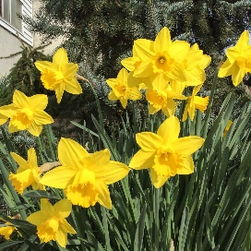
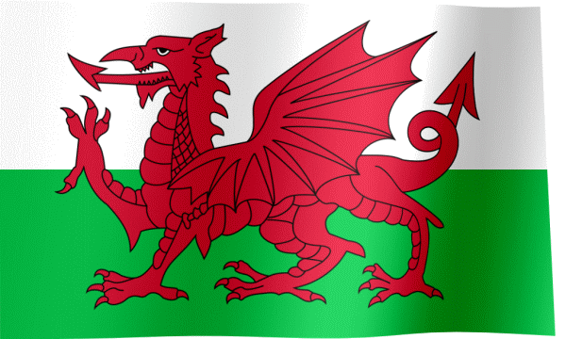
Y6 Spring Term Homework menu
This Photo by Unknown Author is licensed under CC BY
‘Wonderful Wales’

