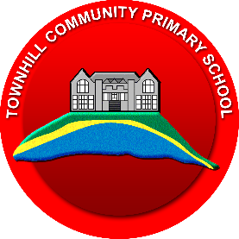
Townhill Community School
Community Champions
A huge thank-you to our wonderful Community Champions at Townhill Community School, who worked alongside the knitting group at Townhill Library. The knitting group have been busy knitting poppies at the library, and our pupils have supported their efforts by helping to sell them within the community. Together, they have raised an impressive £75 for charity.
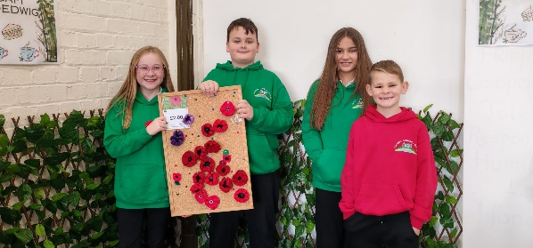
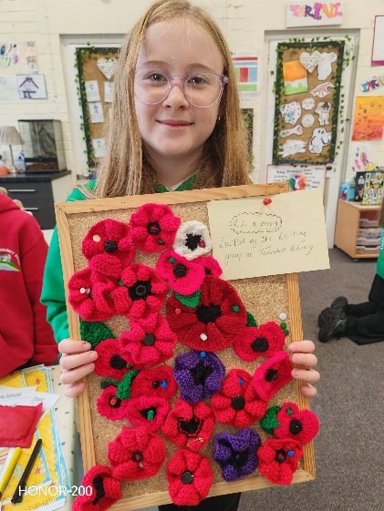
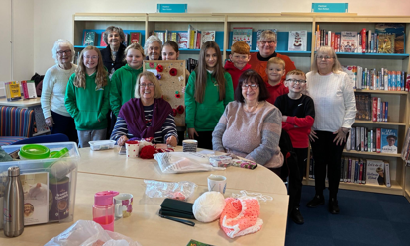
We are extremely proud of the children’s dedication and enthusiasm, and we look forward to seeing the Community Champions continue their partnership with the knitting group in the future.

