Maths and Numeracy | Language, Literacy and Communication | Science and Technology | Humanities | Health and Well Being | Expressive Arts
Research old British Currency and write some word problems for World War 2. | Write a poem about the War. You can choose which type of poem you write e.g. acrostic, haiku, rhyming. | Design and test out a parachute that would allow a member of the RAF to land safely. | Research and write 10 facts about Anne Frank. | Write the ingredients and method of a wartime recipe . | Make a 3D model of an artefact from WW2.
Accurately weigh out your ingredients to make a dish from the wartime. | Imagine you are an evacuee in World War 2. Write a diary entry for the first day you spent away from home. | Log in to HWB and Office365. Create a powerpoint about ‘Battles and Conflicts.’ | Research what school life was like for children in WW2. | Can you cook a wartime recipe with a member of your family? | Design a ‘Battles and Conflicts’ themed board game.
Find out the cost of rationed items. How much would you have spent in a week? Fortnight? A month? | Write a newspaper report about a famous battle in British history. | ‘Make do and Mend.’  Can you make something new out of something old? | Compare and contrast fashion of British wartime and today. | Design your own ‘code breaker’ with a friend or family member. | Draw or paint a scene from WW2.
Create a graph comparing the size of armies from different nations | Visit your local library and find some books about WW2. Present some of the information you found in a way of your choice. | Research what the ‘blackout’ was and the effect it had on people. What would you have invented to combat this problem? | Create a timeline of events that occurred in WW2. | Talk to a family member, neighbour or someone you know that was alive in World War 2. Share any stories with your class | Research popular styles of dance from the 1940’s. Can you record a video of yourself doing one of these styles of dance?
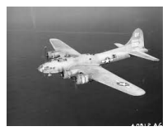
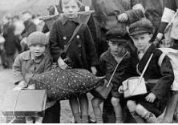
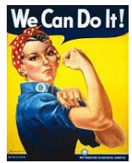
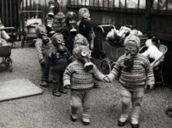
Year 6 Autumn Term Homework Menu
‘Battles and Conflicts’

